Contents
INTRODUCTION 1
INSTALLING THE MYSQL COMMUNITY SERVER 1
STARTING / STOPPING MYSQL SERVER 6
INSTALLING THE MYSQL WORKBENCH 8

INTRODUCTION

There are two software that needs to be installed:
- MySQL Community Server:
The MySQL Community Server is an open-source database management system used for storing and managing data.
Visit the official MySQL website https://dev.mysql.com/downloads/mysql/ and download the installer for MySQL Community Server 8.4.5 LTS that matches your operating system.
- MySQL Workbench.
This is the application tool that you will use to manage your databases as well as write and test your SQL scripts.
Visit the official MySQL website to download the software. https://dev.mysql.com/downloads/workbench/

INSTALLING THE MYSQL COMMUNITY SERVER
- There’s no need to login or sign-up.
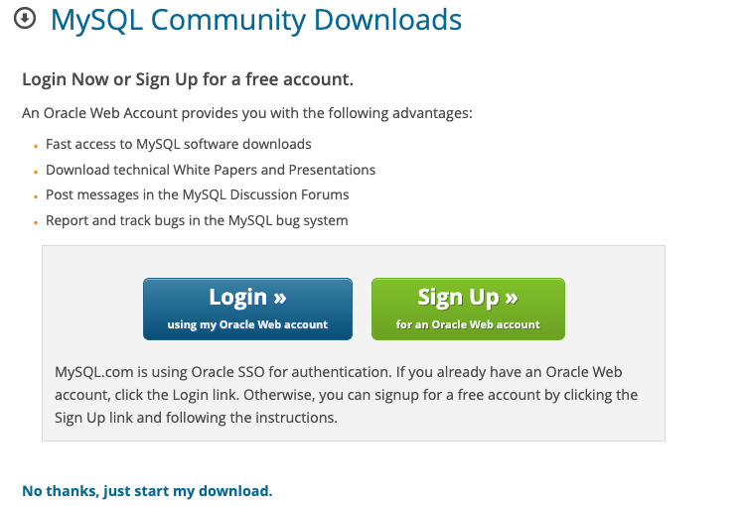
- In the download folder of your laptop, you will find the MySQL installation package. Double click the icon to activate it.
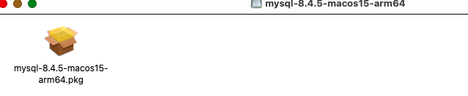
- The red arrow and/or box indicates the ‘button’ you should select. When prompted to enter root password, we recommend you enter RP738964$ so that if you forget you can refer to this document for the password. If you enter your own password, you MUST remember it otherwise you will need to uninstall and reinstall MySQL Server.

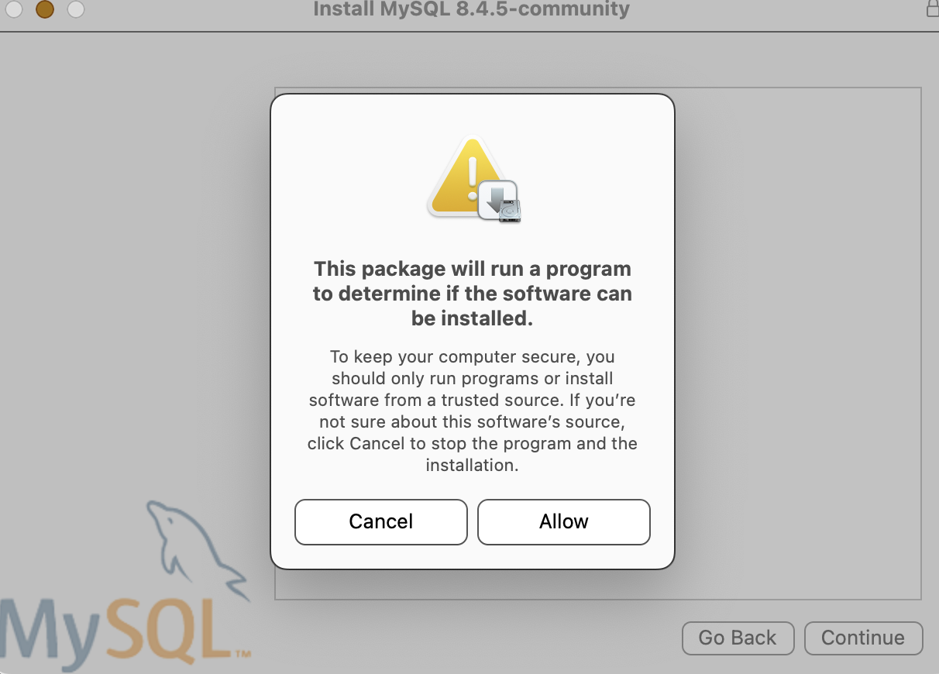
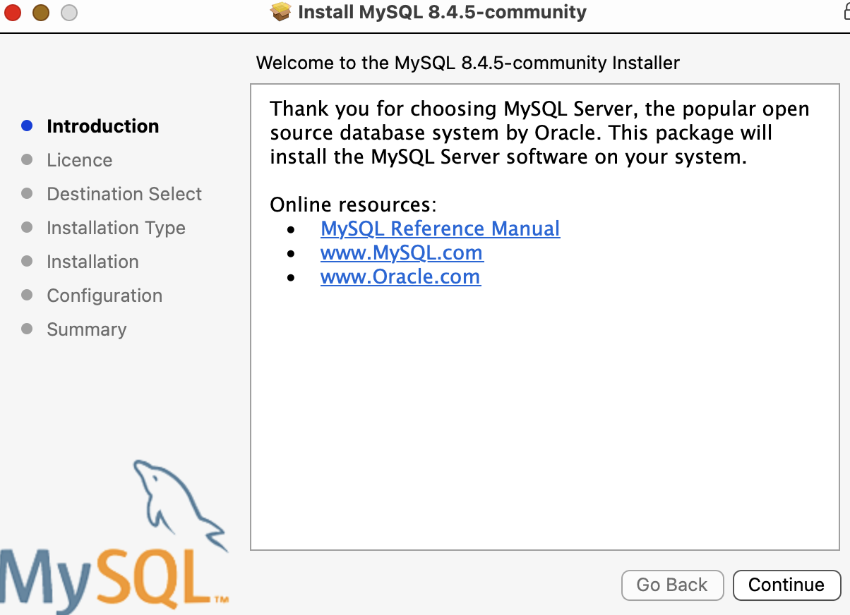

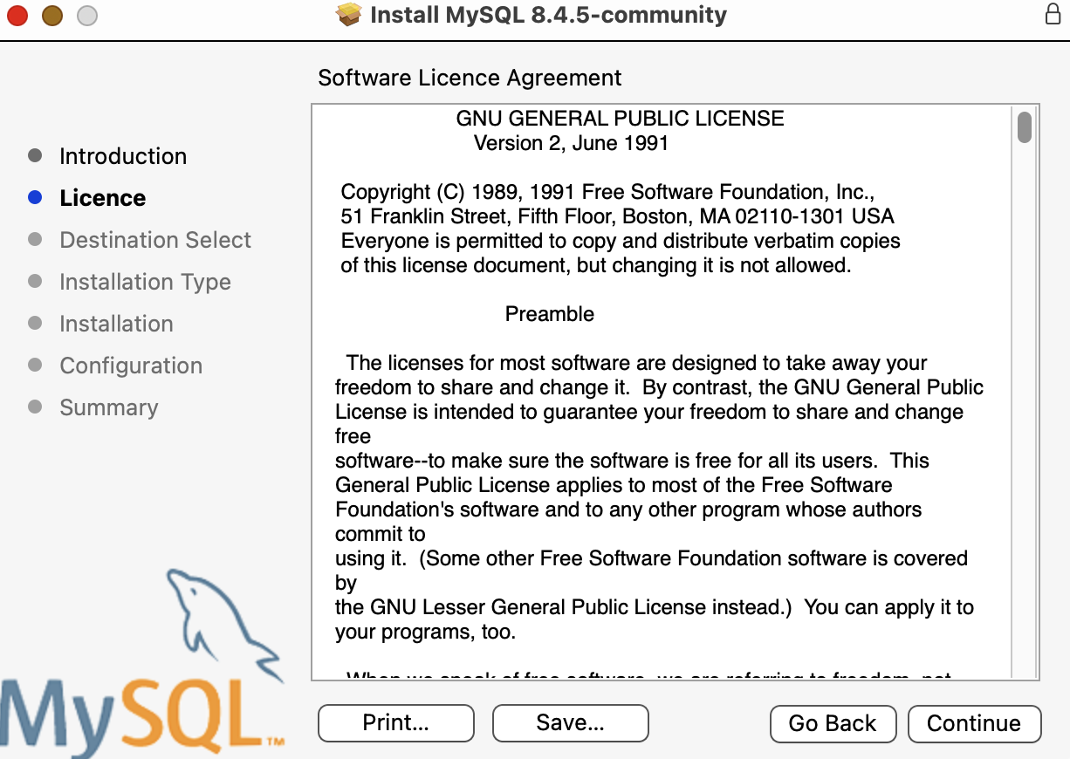
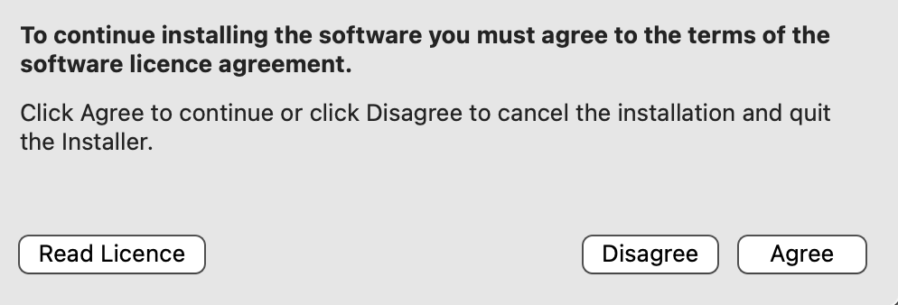

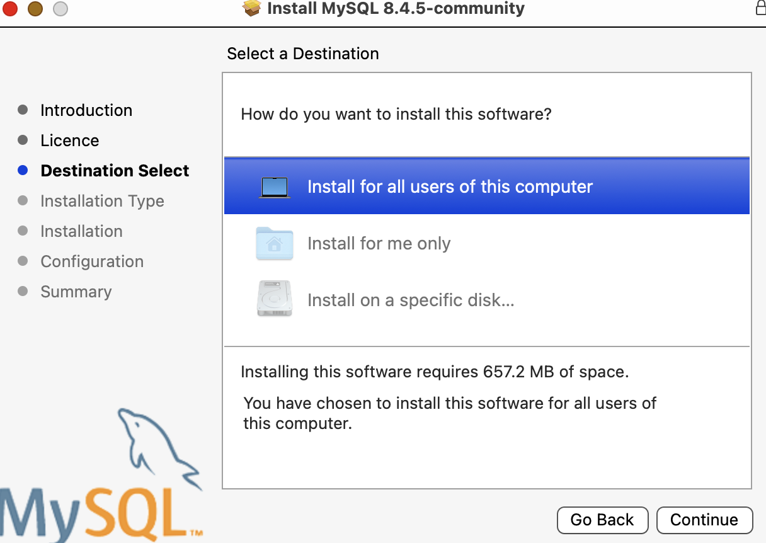

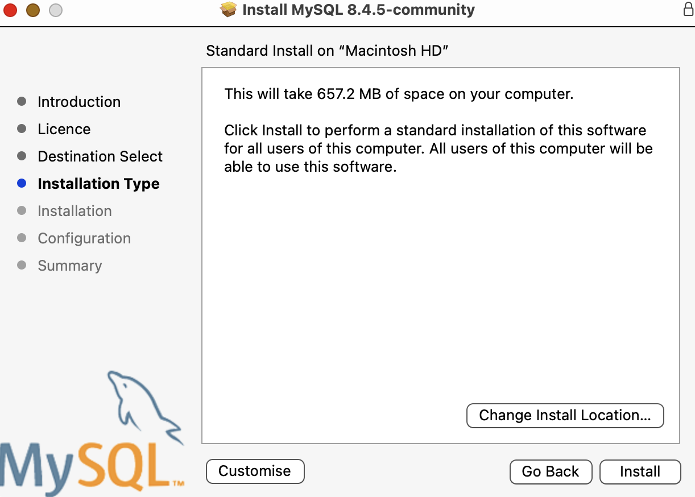

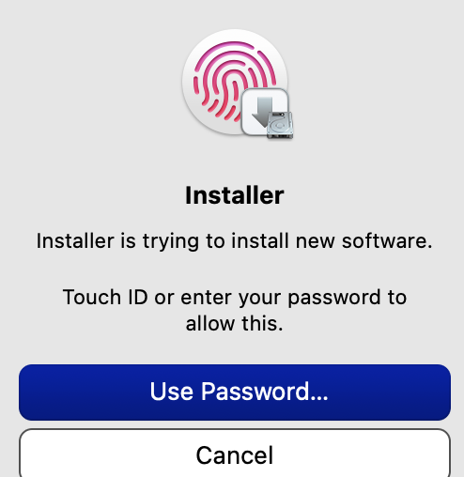

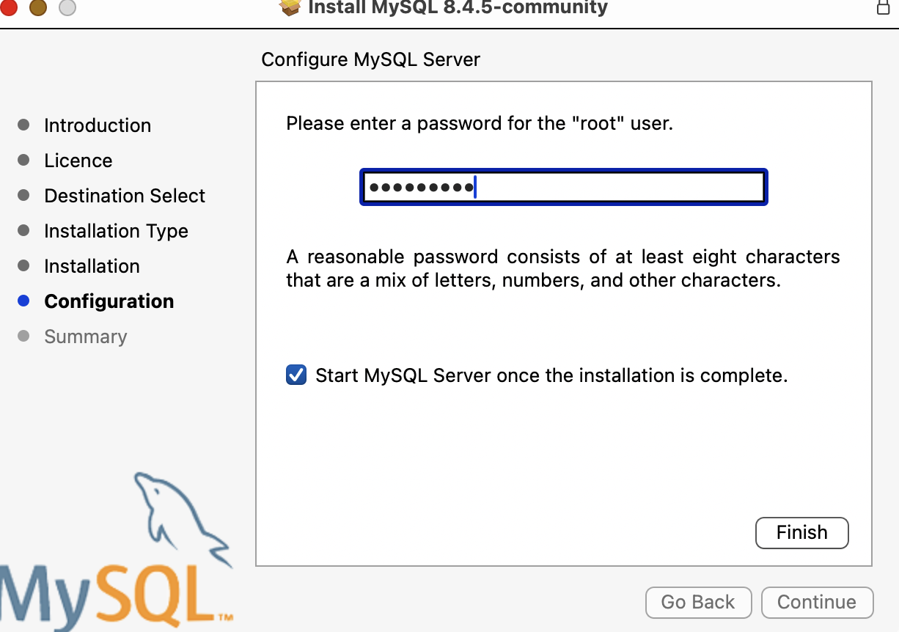
Enter RP738964$
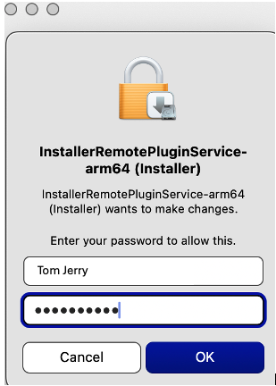
Enter your MAC laptop admin password

STARTING / STOPPING MYSQL SERVER
- Open System Preferences: Click the Apple menu, then select "System Preferences."
- Select MySQL: Look for and select the "MySQL" preference panel. This panel will be installed as part of the MySQL Server installation.
- Start the Server: Within the MySQL preference panel, click the "Start MySQL Server" button. You may be prompted to enter the MySQL Server Root password (RP738964$)This will initiate the MySQL server process.

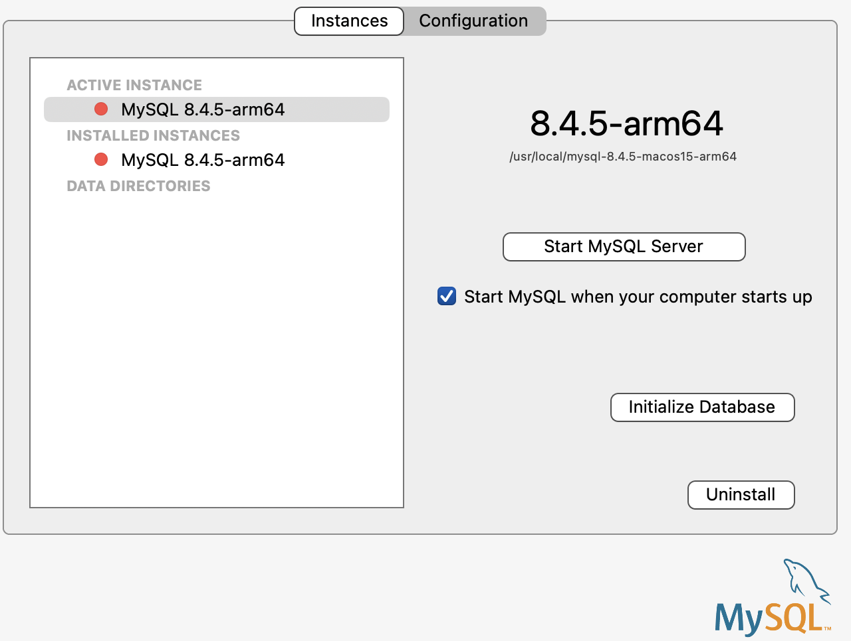

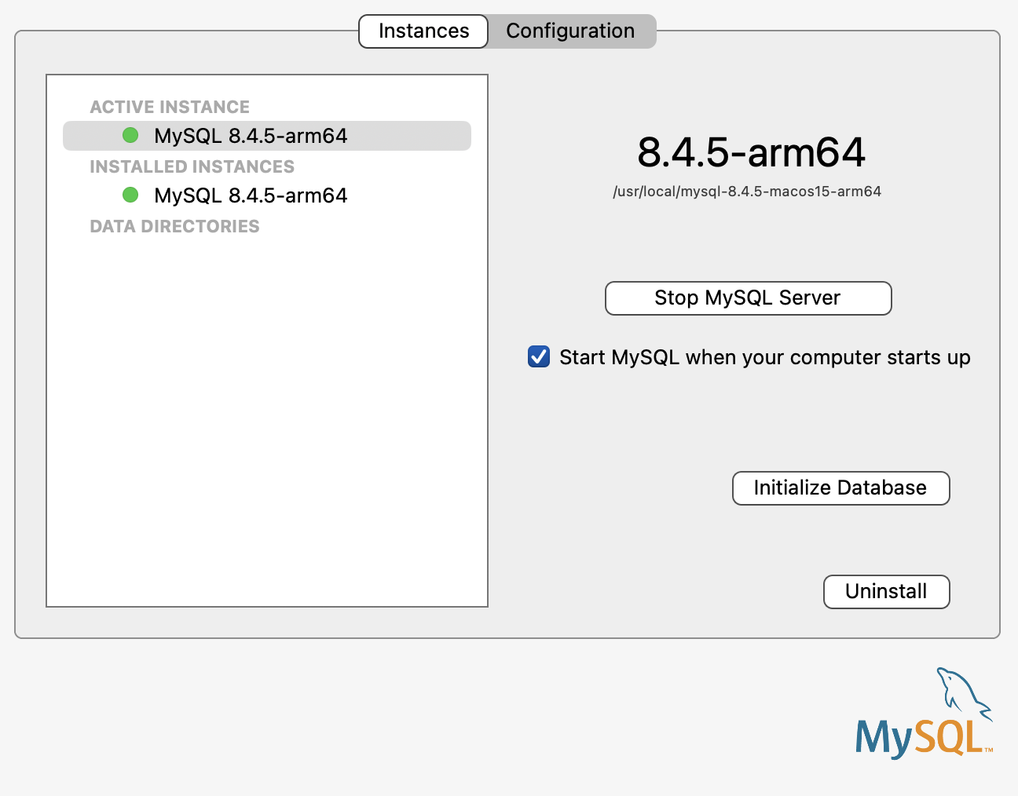

INSTALLING THE MYSQL WORKBENCH
- You do not need to sign-up or log in.
- You will find the MySQL Workbench installation package in the download folder of your laptop. Double-click the icon to begin the installation.
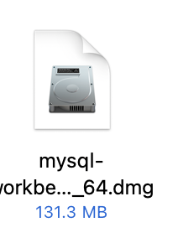
- Draw the MySQL Workbench mascot to the Applications folder, following the direction of the arrow.
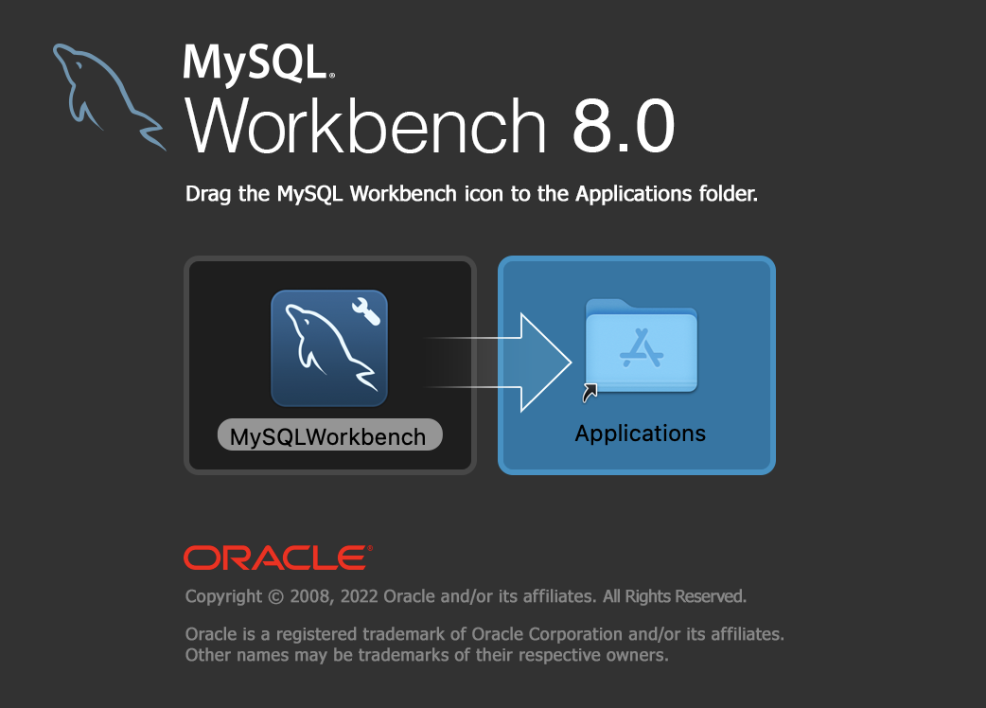

- You can find the MySQL Workbench app by selecting your Application Launchpad.
